Title: Brainstorming for “Garage Management system”
Objective:
To explore various possibilities for improving garage operations through automation and customer relationship management tools.
Process:
- Conducted brainstorming sessions to identify the major challenges in traditional garage operations such as:
  - Manual job tracking and repair scheduling.
  - Difficulty in maintaining service and billing records.
  - Lack of customer follow-up and feedback management.
  - Inefficient data handling and limited reporting capabilities.
- Explored cloud-based platforms and finalized Salesforce as the ideal CRM solution due to:
  - Customizable data objects and automation tools.
  - Real-time customer engagement.
  - Integrated dashboards and reports for data insights.
- Identified core system components:
  - Customer Management
  - Service Records
  - Appointment Scheduling
  - Billing & Feedback
  - Performance Analytics
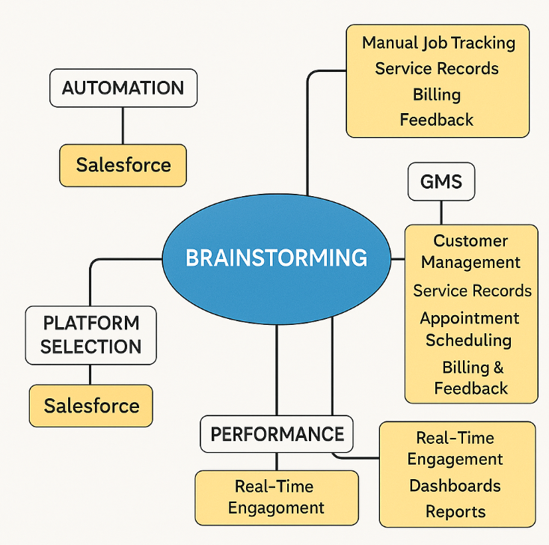
Outcome:
A clear conceptual map of the system was created, highlighting the modules and data relationships to be implemented in Salesforce.
Sub-Phase 2: Define Problem Statement
Objective:
To define the core problem that the project aims to solve and establish measurable goals.
Defined Problem:
Garage operations often face difficulties in managing customer data, tracking repair jobs, and maintaining accurate service histories. The absence of an integrated system results in inefficiencies, missed appointments, and poor customer satisfaction.
Solution Approach:
Implementing a Salesforce-based Garage Management System that:
- Centralizes customer, vehicle, and service data.
- Automates appointment booking, job tracking, and invoicing.
- Enables easy access to reports and dashboards for better decision-making.
- Improves communication between customers and garage staff through cloud access.
Outcome:
A clear, actionable problem statement guiding all upcoming phases — ensuring the system design directly addresses user pain points.
🔹 Sub-Phase 3: Empathy Map
Objective:
To understand user needs, emotions, and expectations to ensure the system design remains customer-centric.
User Groups Identified:
- Garage Owners / Managers – Need efficient tracking of jobs, revenue, and staff performance.
- Mechanics / Technicians – Require a simple interface to log services and update repair progress.
- Customers – Expect transparency, easy booking, and timely updates about their vehicles.
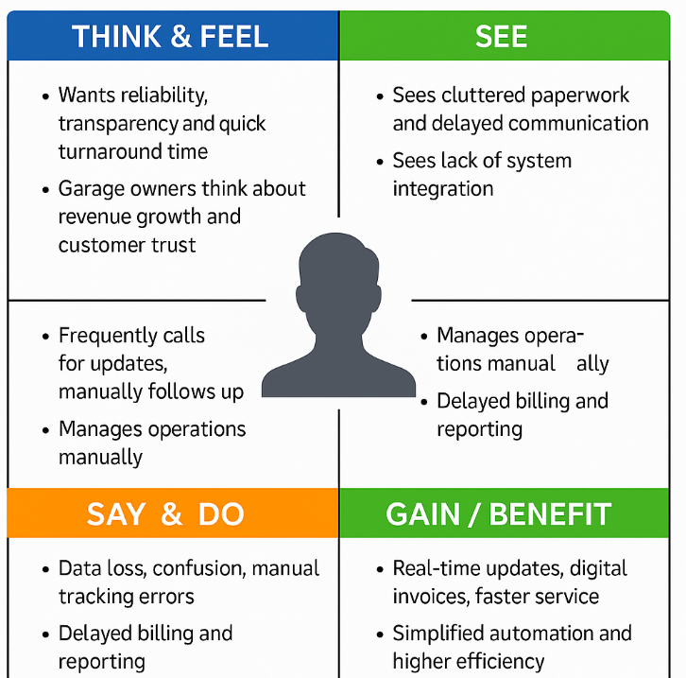
Empathy Map Components:
Think & Feel | See | Say & Do | Pain Points | Gain / Benefit
Want reliability, transparency, and quick turnaround time | See cluttered paperwork and delayed communication | Frequently call for updates, manually follow-up | Data loss, confusion, manual tracking errors | Real-time updates, digital invoices, faster service
Garage owners think about revenue growth and customer trust | See lack of system integration | Manage operations manually | Delayed billing and reporting | Simplified automation and higher efficiency

Outcome:
A clear understanding of user perspectives that helped in shaping user-friendly interfaces, relevant data objects (Customer, Appointment, Service Record, Billing & Feedback), and smooth workflow automation.

